Diapositive 1 |  | ___________________________________  ___________________________________  ___________________________________  ___________________________________  ___________________________________  ___________________________________  ___________________________________
Diapositive 2 |  | ___________________________________  ___________________________________  ___________________________________  ___________________________________  ___________________________________  ___________________________________  ___________________________________
Diapositive 3 | 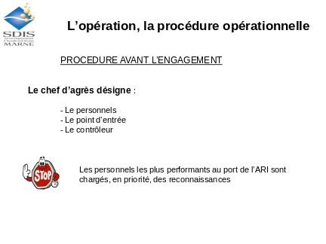 | ___________________________________  ___________________________________  ___________________________________  ___________________________________  ___________________________________  ___________________________________  ___________________________________
Diapositive 4 |               

